**VISVESVARAYA TECHNOLOGICAL UNIVERSITY**

**“JnanaSangama”, Belgaum -590014, Karnataka.**



**LAB REPORT**

**On**

**DATA STRUCTURES (23CS3PCDST)**

**Submitted by**

**Rajinder Kumar**

**1BM23CS260**

**in partial fulfillment for the award of the degree of**

**BACHELOR OF ENGINEERING**

**in**

**COMPUTER SCIENCE AND ENGINEERING**



**B.M.S. COLLEGE OF ENGINEERING**

**(Autonomous Institution under VTU)**

**BENGALURU-560019**

**September 2024-January 2025**

**B. M. S. College of Engineering,**

**Bull Temple Road, Bangalore 560019**

**(Affiliated To Visvesvaraya Technological University, Belgaum)**

**Department of Computer Science and Engineering**



This is to certify that the Lab work entitled **“DATA STRUCTURES”** carried out by   
Rajinder Kumar**(1BM23CS260)**, who is bonafide student of **B. M. S. College of Engineering**. It is in partial fulfillment for the award of **Bachelor of Engineering in Computer Science and Engineering** of the Visvesvaraya Technological University, Belgaum during the year 2024-25. The Lab report has been approved as it satisfies the academic requirements in respect of Data structures Lab - **(23CS3PCDST)**work prescribed for the said degree.

**Prof. Lakshmi Neelima M** **Dr. Kavitha Sooda**

Assistant Professor Professor and Head

Department of CSE Department of CSE

BMSCE, Bengaluru BMSCE, Bengaluru

**Index Sheet**

|  |  |  |
| --- | --- | --- |
| **Sl.**  **No.** | **Experiment Title** | **Page No.** |
| 1 | **Working of Stack using Array** | 4 |
| 2 | 1. **Infix to PostFix** 2. **LeetCode-Majority Element** | 9 |
| 3 | 1. **Working of a queue of integers using an array** 2. **working of a circular queue of integers using an array** | 13 |
| 4 | **a) Implementation of SinglyLinkedList {Creation, Insersion,Display}**  **b) LeetCode- Game Of two Stack** | 22 |
| 5 | 1. **Implementation of SinglyLinkedList {Creation, Deletion ,Display}** 2. **LeetCode- Palindrome Check** | 26 |
| 6 | 1. **Implementation of SinglyLinkedList {Reverse, Sort, Concatenate}** 2. **Implement Single Link List to simulate Stack &Queue Operations** | 30 |
| 7 | 1. **Implement Double Link List {create, Insert, Delete, Display }** | 41 |
| 8 | 1. **Binary Tree Construction, traverse and Display** 2. **LeetCode - PathSum** | 46 |
| 9 | 1. **BFS** 2. **DFS** | 49 |
| 10 | 1. **Linear Probing** | 54 |
| 11 | **LeetCode Problems** | 58 |

**Course outcomes:**

|  |  |
| --- | --- |
| CO1 | Apply the concept of linear and nonlinear data structures. |
| CO2 | Analyze data structure operations for a given problem |
| CO3 | Design and develop solutions using the operations of linear and nonlinear data structure for a given specification. |
| CO4 | Conduct practical experiments for demonstrating the operations of different data structures. |

**LAB Program: 01**

**Write a program to simulate the working of stack using an array with the following:   
a) Push   
b) Pop   
c) Display   
The program should print appropriate messages for stack overflow, stack underflow**

**PROGRAM:**  
  
#include<stdio.h>

//stack operations;

int n;

int stack[20];

int top=-1;

void push(int x){

if(top<=(n-1)){

top++;

stack[top]=x;

}

else{

printf("Stack Overflow \n");

}

}

void pop(){

if(top>=0 ){

int a = stack[top];

stack[top]=0;

printf("Deleted element is %d",a);

top--;

}

else{

printf("Stack Underflow");

}

}

void display(){

for(int i=0; i<=top; i++){

printf("%d",stack[i]);

}

}

void main(){

int choice,num;

printf("Enter the size");

scanf("%d",&n);

printf("Enter the choice \n");

printf("1.Push \n 2.POP \n 3.Display \n 4.Exit \n");

scanf("%d",&choice);

while(choice<4){

if(choice==1){

printf("Enter the number to push");

scanf("%d",&num);

push(num);

}

else if(choice == 2){

pop();

}

else if(choice ==3){

display();

}

else{

break;

}

printf(" \n Enter the choice \n");

scanf("%d",&choice);

}

}

=======

#include<stdio.h>

//stack operations;

int n;

int stack[20];

int top=-1;

void push(int x){

if(top<=(n-1)){

top++;

stack[top]=x;

}

else{

printf("Stack Overflow \n");

}

}

void pop(){

if(top>=0 ){

int a = stack[top];

stack[top]=0;

printf("Deleted element is %d",a);

top--;

}

else{

printf("Stack Underflow");

}

}

void display(){

for(int i=0; i<=top; i++){

printf("%d",stack[i]);

}

}

void main(){

int choice,num;

printf("Enter the size");

scanf("%d",&n);

printf("Enter the choice \n");

printf("1.Push \n 2.POP \n 3.Display \n 4.Exit \n");

scanf("%d",&choice);

while(choice<4){

if(choice==1){

printf("Enter the number to push");

scanf("%d",&num);

push(num);

}

else if(choice == 2){

pop();

}

else if(choice ==3){

display();

}

else{

break;

}

printf(" \n Enter the choice \n");

scanf("%d",&choice);

}

}

**Output:**

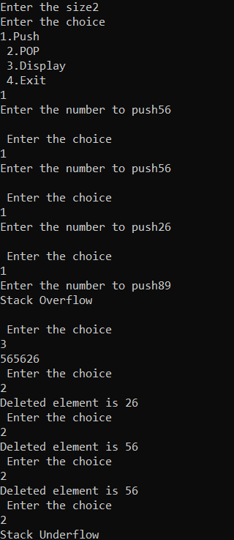

**LAB Program:02**

**WAP to convert a given valid parenthesized infix arithmetic expression to postfix expression. The expression consists of single character operands and the binary operators + (plus), - (minus), * (multiply) and / (divide)**

**Program:**

#include<stdio.h>

#include<string.h>

char infix[20];

int pos = -1;

char postfix[20];

char result[20];

void push(char a) {

pos++;

postfix[pos] = a;

}

char pop() {

char temp = postfix[pos];

postfix[pos] = 0;

pos--;

return temp;

}

int precedence(char c) {

if(c == '+' || c == '-') {

return 1;

} else if(c == '*' || c == '/') {

return 2;

} else if(c == '^') {

return 3;

}

return 0;

}

void infixtoPostfix() {

int resind = 0;

push('(');

int index = 0;

int len = strlen(infix);

infix[len] = ')';

len++;

while(index < len) {

if(infix[index] == '(') {

push('(');

} else if(infix[index] == ')') {

while(postfix[pos] != '(') {

char temp = pop();

result[resind] = temp;

resind++;

}

pop();

} else if(infix[index] == '+' || infix[index] == '-' || infix[index] == '*' || infix[index] == '/' || infix[index] == '^') {

while(pos >= 0 && precedence(infix[index]) <= precedence(postfix[pos])) {

char temp = pop();

result[resind] = temp;

resind++;

}

push(infix[index]);

} else {

result[resind] = infix[index];

resind++;

}

index++;

}

result[resind] = '\0';

}

int main() {

printf("Enter the value infix exp: ");

scanf("%s", infix);

infixtoPostfix();

printf("Postfix expression: ");

for(int i = 0; i < strlen(result); i++) {

printf("%c", result[i]);

}

printf("\n");

return 0;

}

**Output:**

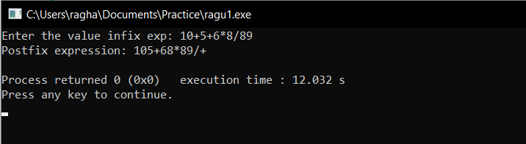

**LABProgram:03-a**

**a) WAP to simulate the working of a queue of integers using an array. Provide the following operations: Insert, Delete, Display The program should print appropriate messages for queue empty and queue overflow conditions  
  
PROGRAM:**

#include<stdio.h>

#define MAX 4

int queue[MAX];

int rear = -1;

int front = -1;

void insert(int n){

    if(rear == MAX-1){

        printf("Queue Overflow \n");

        return;

    }

    if(rear == -1){

        front = 0;

        rear = 0;

        queue[rear] = n;

    }

    else{

        rear = (rear + 1) % MAX;

        queue[rear] = n;

    }

    printf("Element inserted \n");

}

void deleteel(){

    if(front == -1 || front == rear){

        printf("Queue underflow \n");

        return;

    }

    int temp = queue[front];

    if(front == rear){

        front = -1;

        rear = -1;

    }

    else{

        front = (front + 1) % MAX;

    }

    printf("Deleted element is = %d \n",temp);

}

void display(){

    if(front == -1){

        printf("Queue is empty \n");

        return;

    }

    if(rear >= front){

        for(int i = front; i <= rear; i++){

            printf("%d ", queue[i]);

        }

    }

    else{

        for(int i = front; i < MAX; i++){

            printf("%d ", queue[i]);

        }

        for(int i = 0; i <= rear; i++){

            printf("%d ", queue[i]);

        }

    }

    printf("\n");

}

int main(){

    int k;

    k = 0;

    while(k != 4){

        printf("Enter your choice \n");

        printf("1.Insert \n 2. delete \n 3.Display \n 4.Exit \n");

        scanf("%d",&k);

        if(k == 1){

            printf("Enter the element to be inserted = ");

            int n;

            scanf("%d",&n);

            insert(n);

            continue;

        }

        else if(k == 2){

            deleteel();

            continue;

        }

        else if(k == 3){

            display();

            continue;

        }

        else if(k == 4){

            printf("Thank you");

            break;

        }

    }

    return 0;

}

**OUTPUT:**

OUTPUT

Enter your choice

1.Insert

 2. delete

 3.Display

 4.Exit

1

Enter the element to be inserted = 56

Element inserted

Enter your choice

1.Insert

 2. delete

 3.Display

 4.Exit

1

Enter the element to be inserted = 78

Element inserted

Enter your choice

1.Insert

 2. delete

 3.Display

 4.Exit

1

Enter the element to be inserted = 69

Element inserted

Enter your choice

1.Insert

 2. delete

 3.Display

 4.Exit

1

Enter the element to be inserted = 45

Element inserted

Enter your choice

1.Insert

 2. delete

 3.Display

 4.Exit

1

Enter the element to be inserted = 47

Queue Overflow

Enter your choice

1.Insert

 2. delete

 3.Display

 4.Exit

3

56 78 69 45

Enter your choice

1.Insert

 2. delete

 3.Display

 4.Exit

2

Deleted element is = 56

Enter your choice

1.Insert

 2. delete

 3.Display

 4.Exit

2

Deleted element is = 78

Enter your choice

1.Insert

 2. delete

 3.Display

 4.Exit

2

Deleted element is = 69

Enter your choice

1.Insert

 2. delete

 3.Display

 4.Exit

2

Queue underflow

Enter your choice

1.Insert

 2. delete

 3.Display

 4.Exit

3

45

Enter your choice

1.Insert

 2. delete

 3.Display

 4.Exit

2

Queue underflow

Enter your choice

1.Insert

 2. delete

 3.Display

 4.Exit

3

45

Enter your choice

1.Insert

 2. delete

 3.Display

 4.Exit

4

Thank you

**LabProgram3-b**

**b ) WAP to simulate the working of a circular queue of integers using an array. Provide the following operations: Insert, Delete & Display The program should print appropriate messages for queue empty and queue overflow conditions**

**PROGRAM:**

#include<stdio.h>

#define MAX 4

int queue[MAX];

int rear = -1;

int front = -1;

void insert(int n){

    if((rear + 1) % MAX == front){

        printf("Queue Overflow \n");

        return;

    }

    if(rear == -1){

        front = 0;

        rear = 0;

        queue[rear] = n;

    } else {

        rear = (rear + 1) % MAX;

        queue[rear] = n;

    }

    printf("Element inserted \n");

}

void deleteel(){

    if(front == -1){

        printf("Queue underflow \n");

        return;

    }

    int temp = queue[front];

    if(front == rear){

        front = -1;

        rear = -1;

    } else {

        front = (front + 1) % MAX;

    }

    printf("Deleted element is = %d \n", temp);

}

void display(){

    if(front == -1){

        printf("Queue is empty \n");

        return;

    }

    if(rear >= front){

        for(int i = front; i <= rear; i++){

            printf("%d ", queue[i]);

        }

    } else {

        for(int i = front; i < MAX; i++){

            printf("%d ", queue[i]);

        }

        for(int i = 0; i <= rear; i++){

            printf("%d ", queue[i]);

        }

    }

    printf("\n");

}

int main(){

    int k;

    k = 0;

    while(k != 4){

        printf("Enter your choice \n");

        printf("1.Insert \n 2. delete \n 3.Display \n 4.Exit \n");

        scanf("%d",&k);

        if(k == 1){

            printf("Enter the element to be inserted = ");

            int n;

            scanf("%d",&n);

            insert(n);

            continue;

        }

        else if(k == 2){

            deleteel();

            continue;

        }

        else if(k == 3){

            display();

            continue;

        }

        else if(k == 4){

            printf("Thank you");

            break;

        }

    }

    return 0;

}

**OUTPUT:**

OUTPUT

Enter your choice

1.Insert

 2. delete

 3.Display

 4.Exit

1

Enter the element to be inserted = 45

Element inserted

Enter your choice

1.Insert

 2. delete

 3.Display

 4.Exit

1

Enter the element to be inserted = 89

Element inserted

Enter your choice

1.Insert

 2. delete

 3.Display

 4.Exit

1

Enter the element to be inserted = 45

Element inserted

Enter your choice

1.Insert

 2. delete

 3.Display

 4.Exit

1

Enter the element to be inserted = 96

Element inserted

Enter your choice

1.Insert

 2. delete

 3.Display

 4.Exit

3

45 89 45 96

Enter your choice

1.Insert

 2. delete

 3.Display

 4.Exit

2

Deleted element is = 45

Enter your choice

1.Insert

 2. delete

 3.Display

 4.Exit

2

Deleted element is = 89

Enter your choice

1.Insert

 2. delete

 3.Display

 4.Exit

3

45 96

Enter your choice

1.Insert

 2. delete

 3.Display

 4.Exit

1

Enter the element to be inserted = 89

Element inserted

Enter your choice

1.Insert

 2. delete

 3.Display

 4.Exit

1

Enter the element to be inserted = 56

Element inserted

Enter your choice

1.Insert

 2. delete

 3.Display

 4.Exit

3

45 96 89 56

Enter your choice

1.Insert

 2. delete

 3.Display

 4.Exit

4

Thank you

**LabProgram 04**

**WAP to Implement Singly Linked List with following operations a) Createalinkedlist. b) Insertion of a node at first position, at any position and at end of list. Display the contents of the linked list.**

**PROGRAM:**

#include<stdio.h>

#include<malloc.h>

#include<stdlib.h>

struct node{

    int data;

    struct node* next;

};

struct node* start = NULL;

//creation of linked list

struct node* create(struct node* start){

    printf("Enter the values for linked list:\n");

    int val;

    scanf("%d",&val);

    while(val!=-1){

        struct node* newnode = (struct node*)malloc(sizeof(struct node));

        newnode->data = val;

        newnode->next = NULL;

        if(start == NULL){

            start = newnode;

        }

        else{

            struct node* temp = start;

            while(temp->next != NULL){

                temp = temp->next;

            }

            temp->next = newnode;

        }

        printf("Enter the next value for linked list (-1 to stop):\n");

        scanf("%d",&val);

    }

    return start;

}

//insertion at the beginning

struct node* insertatbeg(struct node* start){

    printf("Enter the val to be inserted at the beginning:\n");

    int val;

    scanf("%d",&val);

    struct node*temp = start;

    struct node* newnode = (struct node*)malloc(sizeof(struct node));

    newnode->data= val;

    newnode->next = temp;

    start = newnode;

    return start;

}

//insertion at the end of ll

struct node* insertend(struct node* start){

    int val;

    printf("Enter the val to be inserted at the end:\n");

    scanf("%d",&val);

    struct node*temp = start;

    while(temp->next !=NULL){

        temp = temp->next;

    }

    struct node* newnode = (struct node*)malloc(sizeof(struct node));

    newnode->data = val;

    newnode->next = NULL;

    temp->next = newnode;

    return start;

}

//insert at kth position of ll

struct node* insertatk(struct node* start,int k){

    int val;

    printf("Enter the val to be inserted at %dth posn \n",k);

    scanf("%d",&val);

    struct node* newnode = (struct node*)malloc(sizeof(struct node));

    newnode->data = val;

    struct node*temp = start;

    while(k>1){

        k--;

        temp = temp->next;

    }

    newnode->next = temp->next;

    temp->next = newnode;

    return start;

}

void display(struct node* start)

{

   struct node* temp = start;

   while(temp != NULL){

    printf("%d-> ", temp->data);

    temp = temp->next;

   }

   printf("NULL \n");

}

//delete head

struct node* deletebeg(struct node*start){

    struct node* temp = start;

    start = start->next;

    free(temp);

    return start;

}

//delete at end

struct node* deleteend(struct node*start){

    struct node* temp = start;

    while(temp->next->next!=NULL){

        temp = temp->next;

    }

    temp->next = NULL;

    return start;

}

//delete at kth posn

struct node* deletekpos(struct node*start , int k){

    struct node* temp = start;

    if(k==1){

        start = start->next;

    }

    else{

        while(k>2){

            k--;

            temp = temp->next;

        }

        temp->next = temp->next->next;

    }

    return start;

}

int main(){

    start = create(start);

    display(start);

    start=insertatbeg(start);

    display(start);

    start = insertend(start);

    display(start);

    start = insertatk(start,3);

    display(start);

    start = deletebeg(start);

    display(start);

    start = deleteend(start);

    display(start);

    start = deletekpos(start, 2);

    display(start);

}

**OUTPUT:**

Enter the values for linked list:

1

Enter the next value for linked list (-1 to stop):

2

Enter the next value for linked list (-1 to stop):

3

Enter the next value for linked list (-1 to stop):

4

Enter the next value for linked list (-1 to stop):

5

Enter the next value for linked list (-1 to stop):

6

Enter the next value for linked list (-1 to stop):

-1

1-> 2-> 3-> 4-> 5-> 6-> NULL

Enter the val to be inserted at the beginning:

45

45-> 1-> 2-> 3-> 4-> 5-> 6-> NULL

Enter the val to be inserted at the end:

96

45-> 1-> 2-> 3-> 4-> 5-> 6-> 96-> NULL

Enter the val to be inserted at 3th posn

5

45-> 1-> 2-> 5-> 3-> 4-> 5-> 6-> 96-> NULL

1-> 2-> 5-> 3-> 4-> 5-> 6-> 96-> NULL

1-> 2-> 5-> 3-> 4-> 5-> 6-> NULL

1-> 5-> 3-> 4-> 5-> 6-> NULL

**LabProgram:05**

**WAP to Implement Singly Linked List with following operations a) Create a linked list. b) Deletion of first element, specified element and last element in the list. c) Display the contents of the linked list.**

**Program:**

#include<stdio.h>

#include<malloc.h>

#include<stdlib.h>

struct node{

    int data;

    struct node* next;

};

struct node* start = NULL;

//creation of linked list

struct node* create(struct node* start){

    printf("Enter the values for linked list:\n");

    int val;

    scanf("%d",&val);

    while(val!=-1){

        struct node* newnode = (struct node*)malloc(sizeof(struct node));

        newnode->data = val;

        newnode->next = NULL;

        if(start == NULL){

            start = newnode;

        }

        else{

            struct node* temp = start;

            while(temp->next != NULL){

                temp = temp->next;

            }

            temp->next = newnode;

        }

        printf("Enter the next value for linked list (-1 to stop):\n");

        scanf("%d",&val);

    }

    return start;

}

//insertion at the beginning

struct node* insertatbeg(struct node* start){

    printf("Enter the val to be inserted at the beginning:\n");

    int val;

    scanf("%d",&val);

    struct node*temp = start;

    struct node* newnode = (struct node*)malloc(sizeof(struct node));

    newnode->data= val;

    newnode->next = temp;

    start = newnode;

    return start;

}

//insertion at the end of ll

struct node* insertend(struct node* start){

    int val;

    printf("Enter the val to be inserted at the end:\n");

    scanf("%d",&val);

    struct node*temp = start;

    while(temp->next !=NULL){

        temp = temp->next;

    }

    struct node* newnode = (struct node*)malloc(sizeof(struct node));

    newnode->data = val;

    newnode->next = NULL;

    temp->next = newnode;

    return start;

}

//insert at kth position of ll

struct node* insertatk(struct node* start,int k){

    int val;

    printf("Enter the val to be inserted at %dth posn \n",k);

    scanf("%d",&val);

    struct node* newnode = (struct node*)malloc(sizeof(struct node));

    newnode->data = val;

    struct node*temp = start;

    while(k>1){

        k--;

        temp = temp->next;

    }

    newnode->next = temp->next;

    temp->next = newnode;

    return start;

}

void display(struct node* start)

{

   struct node* temp = start;

   while(temp != NULL){

    printf("%d-> ", temp->data);

    temp = temp->next;

   }

   printf("NULL \n");

}

//delete head

struct node* deletebeg(struct node*start){

    struct node* temp = start;

    start = start->next;

    free(temp);

    return start;

}

//delete at end

struct node* deleteend(struct node*start){

    struct node* temp = start;

    while(temp->next->next!=NULL){

        temp = temp->next;

    }

    temp->next = NULL;

    return start;

}

//delete at kth posn

struct node* deletekpos(struct node*start , int k){

    struct node* temp = start;

    if(k==1){

        start = start->next;

    }

    else{

        while(k>2){

            k--;

            temp = temp->next;

        }

        temp->next = temp->next->next;

    }

    return start;

}

int main(){

    start = create(start);

    display(start);

    start=insertatbeg(start);

    display(start);

    start = insertend(start);

    display(start);

    start = insertatk(start,3);

    display(start);

    start = deletebeg(start);

    display(start);

    start = deleteend(start);

    display(start);

    start = deletekpos(start, 2);

    display(start);

}

**OUTPUT:**

Enter the values for linked list:

1

Enter the next value for linked list (-1 to stop):

2

Enter the next value for linked list (-1 to stop):

3

Enter the next value for linked list (-1 to stop):

4

Enter the next value for linked list (-1 to stop):

5

Enter the next value for linked list (-1 to stop):

6

Enter the next value for linked list (-1 to stop):

-1

1-> 2-> 3-> 4-> 5-> 6-> NULL

Enter the val to be inserted at the beginning:

45

45-> 1-> 2-> 3-> 4-> 5-> 6-> NULL

Enter the val to be inserted at the end:

96

45-> 1-> 2-> 3-> 4-> 5-> 6-> 96-> NULL

Enter the val to be inserted at 3th posn

5

45-> 1-> 2-> 5-> 3-> 4-> 5-> 6-> 96-> NULL

1-> 2-> 5-> 3-> 4-> 5-> 6-> 96-> NULL

1-> 2-> 5-> 3-> 4-> 5-> 6-> NULL

1-> 5-> 3-> 4-> 5-> 6-> NULL

**LabProgram-06 -a**

**a) WAP to Implement Single Link List with following operations: Sort the linked list, Reverse the linked list, Concatenation of two linked lists.**

**PROGRAM:**

#include<stdio.h>

#include<stdlib.h>

struct node{

    int data;

    struct node* next;

};

struct node* create(struct node* start){

    printf("Enter the values for linked list:\n");

    int val;

    scanf("%d",&val);

    while(val!=-1){

        struct node* newnode = (struct node*)malloc(sizeof(struct node));

        newnode->data = val;

        newnode->next = NULL;

        if(start == NULL){

            start = newnode;

        }

        else{

            struct node* temp = start;

            while(temp->next != NULL){

                temp = temp->next;

            }

            temp->next = newnode;

        }

        printf("Enter the next value for linked list (-1 to stop):\n");

        scanf("%d",&val);

    }

    return start;

}

struct node* reverse(struct node* start){

    struct node* prev = NULL;

    struct node* current = start;

    struct node* next = NULL;

    while(current != NULL){

        next = current->next;

        current->next = prev;

        prev = current;

        current = next;

    }

    return prev;

}

struct node* concatenate(struct node* start1, struct node* start2){

    if(start1 == NULL) return start2;

    if(start2 == NULL) return start1;

    struct node* temp = start1;

    while(temp->next != NULL){

        temp = temp->next;

    }

    temp->next = start2;

    return start1;

}

struct node* sort(struct node* start){

    struct node* a = start;

    struct node* b;

    while(a != NULL){

        b = a->next;

        while(b != NULL){

            if(a->data > b->data){

                int temp = a->data;

                a->data = b->data;

                b->data = temp;

            }

            b = b->next;

        }

        a = a->next;

    }

    return start;

}

void display(struct node* start)

{

   struct node* temp = start;

   while(temp != NULL){

    printf("%d-> ", temp->data);

    temp = temp->next;

   }

   printf("NULL \n");

}

int main(){

    struct node* start1 = NULL;

    start1 = create(start1);

    display(start1);

    struct node* start2 = NULL;

    start2 = create(start2);

    display(start2);

    start1= concatenate(start1,start2);

    display(start1);

    start1 = sort(start1);

    display(start1);

    start1 = reverse(start1);

    display(start1);

}

**OUTPUT:**

Enter the values for linked list:

1

Enter the next value for linked list (-1 to stop):

4

Enter the next value for linked list (-1 to stop):

2

Enter the next value for linked list (-1 to stop):

3

Enter the next value for linked list (-1 to stop):

7

Enter the next value for linked list (-1 to stop):

-1

1-> 4-> 2-> 3-> 7-> NULL

Enter the values for linked list:

4

Enter the next value for linked list (-1 to stop):

6

Enter the next value for linked list (-1 to stop):

7

Enter the next value for linked list (-1 to stop):

9

Enter the next value for linked list (-1 to stop):

2

Enter the next value for linked list (-1 to stop):

-1

4-> 6-> 7-> 9-> 2-> NULL

1-> 4-> 2-> 3-> 7-> 4-> 6-> 7-> 9-> 2-> NULL

1-> 2-> 2-> 3-> 4-> 4-> 6-> 7-> 7-> 9-> NULL

9-> 7-> 7-> 6-> 4-> 4-> 3-> 2-> 2-> 1-> NULL

**LabProgram 06-b**

**b) WAP to Implement Single Link List to simulate Stack & Queue Operations**

**PROGRAM:**

#include <stdio.h>

#include <stdlib.h>

// Define the Node structure

struct Node {

    int data;

    struct Node* next;

};

// Function to create a new node

struct Node* createNode(int data) {

    struct Node* node = (struct Node*)malloc(sizeof(struct Node));

    node->data = data;

    node->next = NULL;

    return node;

}

// Function to check if the stack is empty

int isEmpty(struct Node* top) {

    return top == NULL;

}

// Function to push an element onto the stack

void push(struct Node** top, int data) {

    struct Node* node = createNode(data);

    node->next = *top;

    *top = node;

    printf("\nPushed %d onto the stack.", data);

}

// Function to pop an element from the stack

int pop(struct Node** top) {

    if (isEmpty(*top)) {

        printf("Stack underflow\n");

        return -1; // Return -1 to indicate the stack is empty

    }

    struct Node* temp = *top;

    int data = temp->data;

    *top = (*top)->next;

    free(temp);

    return data;

}

// Function to display the elements in the stack

void display(struct Node* top) {

    if (isEmpty(top)) {

        printf("Stack is empty\n");

        return;

    }

    struct Node* temp = top;

    printf("\nStack: ");

    while (temp != NULL) {

        printf("%d ", temp->data);

        temp = temp->next;

    }

    printf("\n");

}

// Main function with switch-based menu

int main() {

    struct Node* stack = NULL;

    int choice, value;

    while (1) {

        printf("\nStack Operations Menu:\n");

        printf("1. Push\n");

        printf("2. Pop\n");

        printf("3. Display\n");

        printf("4. Exit\n");

        printf("Enter your choice: ");

        scanf("%d", &choice);

        switch (choice) {

            case 1:

                printf("Enter value to push: ");

                scanf("%d", &value);

                push(&stack, value);

                break;

            case 2:

                value = pop(&stack);

                if (value != -1) { // Check for valid pop operation

                    printf("Popped: %d\n", value);

                }

                break;

            case 3:

                display(stack);

                break;

            case 4:

                printf("Exiting program.\n");

                exit(0);

            default:

                printf("Invalid choice! Please try again.\n");

        }

    }

    return 0;

}

**OUTPUT:**

Stack Operations Menu:

1. Push

2. Pop

3. Display

4. Exit

Enter your choice: 1

Enter value to push: 56

Pushed 56 onto the stack.

Stack Operations Menu:

1. Push

2. Pop

3. Display

4. Exit

Enter your choice: 1

Enter value to push: 15

Pushed 15 onto the stack.

Stack Operations Menu:

1. Push

2. Pop

3. Display

4. Exit

Enter your choice: 1

Enter value to push: 96

Pushed 96 onto the stack.

Stack Operations Menu:

1. Push

2. Pop

3. Display

4. Exit

Enter your choice: 2

Popped: 96

Stack Operations Menu:

1. Push

2. Pop

3. Display

4. Exit

Enter your choice: 2

Popped: 15

Stack Operations Menu:

1. Push

2. Pop

3. Display

4. Exit

Enter your choice: 2

Popped: 56

Stack Operations Menu:

1. Push

2. Pop

3. Display

4. Exit

Enter your choice: 2

Stack underflow

**Implementing Queue:**

**Program:**

#include <stdio.h>

#include <stdlib.h>

struct Node {

    int data;

    struct Node* next;

};

struct Queue {

    struct Node* front;

    struct Node* rear;

};

struct Node* createNode(int data) {

    struct Node* node = (struct Node*)malloc(sizeof(struct Node));

    node->data = data;

    node->next = NULL;

    return node;

}

struct Queue* createQueue() {

    struct Queue* queue = (struct Queue*)malloc(sizeof(struct Queue));

    queue->front = NULL;

    queue->rear = NULL;

    return queue;

}

int isEmpty(struct Queue* queue) {

    return queue->front == NULL;

}

void enqueue(struct Queue* queue, int data) {

    struct Node* node = createNode(data);

    if (queue->rear == NULL) {

        queue->front = queue->rear = node;

        return;

    }

    queue->rear->next = node;

    queue->rear = node;

}

int dequeue(struct Queue* queue) {

    if (isEmpty(queue)) {

        printf("Queue underflow\n");

        return NULL;

    }

    struct Node* temp = queue->front;

    int data = temp->data;

    queue->front = queue->front->next;

    if (queue->front == NULL) queue->rear = NULL;

    free(temp);

    return data;

}

void display(struct Queue* queue) {

    if (isEmpty(queue)) {

        printf("Queue is empty\n");

        return;

    }

    struct Node* temp = queue->front;

    printf("Queue contents:\n");

    while (temp != NULL) {

        printf("%d ", temp->data);

        temp = temp->next;

    }

    printf("\n");

}

int main() {

    struct Queue* queue = createQueue();

    int choice, value;

    while (1) {

        printf("\nQueue Operations Menu:\n");

        printf("1. Enqueue\n");

        printf("2. Dequeue\n");

        printf("3. Display\n");

        printf("4. Exit\n");

        printf("Enter your choice: ");

        scanf("%d", &choice);

        switch (choice) {

            case 1:

                printf("Enter value to enqueue: ");

                scanf("%d", &value);

                enqueue(queue, value);

                printf("Enqueued: %d\n", value);

                break;

            case 2:

                value = dequeue(queue);

                if (value != NULL) {

                    printf("Dequeued: %d\n", value);

                }

                break;

            case 3:

                display(queue);

                break;

            case 4:

                printf("Exiting program.\n");

                exit(0);

            default:

                printf("Invalid choice! Please try again.\n");

        }

    }

    return 0;

}

**OUTPUT:**

Queue Operations Menu:

1. Enqueue

2. Dequeue

3. Display

4. Exit

Enter your choice: 1

Enter value to enqueue: 56

Enqueued: 56

Queue Operations Menu:

1. Enqueue

2. Dequeue

3. Display

4. Exit

Enter your choice: 1

Enter value to enqueue: 78

Enqueued: 78

Queue Operations Menu:

1. Enqueue

2. Dequeue

3. Display

4. Exit

Enter your choice: 1

Enter value to enqueue: 36

Enqueued: 36

Queue Operations Menu:

1. Enqueue

2. Dequeue

3. Display

4. Exit

Enter your choice: 3

Queue contents:

56 78 36

Queue Operations Menu:

1. Enqueue

2. Dequeue

3. Display

4. Exit

Enter your choice: 2

Dequeued: 56

Queue Operations Menu:

1. Enqueue

2. Dequeue

3. Display

4. Exit

Enter your choice: 2

Dequeued: 78

Queue Operations Menu:

1. Enqueue

2. Dequeue

3. Display

4. Exit

Enter your choice: 2

Dequeued: 36

Queue Operations Menu:

1. Enqueue

2. Dequeue

3. Display

4. Exit

Enter your choice: 3

Queue is empty

Queue Operations Menu:

1. Enqueue

2. Dequeue

3. Display

4. Exit

Enter your choice: 2

Queue underflow

**LabProgram 07:**

**WAP to Implement doubly link list with primitive operations a) Create a doubly linked list. b) Insert a new node to the left of the node. c) Delete the node based on a specific value d) Display the contents of the list**

**PROGRAM:**

#include <stdio.h>

#include <malloc.h>

#include <stdlib.h>

struct node

{

    int data;

    struct node *next;

    struct node *prev;

};

struct node *start = NULL;

// creation of linked list

struct node *create(struct node *start)

{

    int data;

    scanf("%d", &data);

    while (data != -1)

    {

        struct node *new_node = (struct node *)malloc(sizeof(struct node));

        new_node->data = data;

        if (start == NULL)

        {

            start = new_node;

            new_node->next = NULL;

            new_node->prev = NULL;

        }

        else

        {

            struct node *temp = start;

            while (temp->next != NULL)

            {

                temp = temp->next;

            }

            temp->next = new_node;

            new_node->prev = temp;

            new_node->next = NULL;

        }

        scanf("%d", &data);

    }

    return start;

}

// insertion at the left of the dll

struct node *insert_left(struct node *start, int data, int val)

{

    struct node *new_node = (struct node *)malloc(sizeof(struct node));

    new_node->data = data;

    if (start == NULL)

    {

        start = new_node;

        new_node->next = NULL;

        new_node->prev = NULL;

        return start;

    }

    struct node *temp = start;

    while (temp->next != NULL && temp->next->data != val)

    {

        temp = temp->next;

    }

    if (start->data == val)

    {

        temp = start;

        new_node->next = temp;

        temp->prev = new_node;

        start = new_node;

    }

    else if (temp->next == NULL)

    {

        printf("Invalid entry \n");

    }

    else

    {

        new_node->next = temp->next;

        temp->next->prev = new_node;

        temp->next = new_node;

        new_node->prev = temp;

    }

    return start;

}

// deletion of particular node

struct node *delete_node(struct node *start, int val)

{

    if (start == NULL)

    {

        return start;

    }

    if (start->data == val)

    {

        struct node *temp = start;

        start = start->next;

        if (start != NULL)

        {

            start->prev = NULL;

        }

        free(temp);

        return start;

    }

    struct node *temp = start;

    while (temp->next != NULL && temp->next->data != val)

    {

        temp = temp->next;

    }

    if (temp->next == NULL)

    {

        return start;

    }

    struct node *del = temp->next;

    temp->next = temp->next->next;

    if (temp->next != NULL)

    {

        temp->next->prev = temp;

    }

    free(del);

    return start;

}

// display

void display(struct node *start)

{

    struct node *temp = start;

    while (temp != NULL)

    {

        printf("%d-> ", temp->data);

        temp = temp->next;

    }

    printf(" NULL \n");

}

int main()

{

    struct node *start = NULL;

    printf("Create the linked list: \n");

    printf("Enter the data to be inserted next press -1 to exit \n");

    start = create(start);

    printf("Linked list created \n");

    display(start);

    printf("Please enter your choice:\n"

           "1. Insert at the left\n"

           "2. Delete Node\n"

           "3. Display\n"

           "4. Exit\n");

    int choice;

    scanf("%d", &choice);

    while (choice != 4)

    {

        switch (choice)

        {

        case 1:

            printf("Enter the data to be inserted: ");

            int data;

            scanf("%d", &data);

            printf("Enter the val before whitch to be inserted \n");

            int val;

            scanf("%d", &val);

            start = insert_left(start, data, val);

            break;

        case 2:

            printf("Enter the value to be deleted  \n");

            scanf("%d", &val);

            start = delete_node(start, val);

            break;

        case 3:

            display(start);

            break;

        default:

            printf("Invalid choice\n");

        }

        scanf("%d",&choice);

    }

}

**OUTPUT:**

Create the linked list:

Enter the data to be inserted next press -1 to exit

89

10

20

30

40

-1

Linked list created

89-> 10-> 20-> 30-> 40->  NULL

Please enter your choice:

1. Insert at the left

2. Delete Node

3. Display

4. Exit

1

Enter the data to be inserted: 45

Enter the val before whitch to be inserted

20

3

89-> 10-> 45-> 20-> 30-> 40->  NULL

2

Enter the value to be deleted

30

3

89-> 10-> 45-> 20-> 40->  NULL

4

**LabProgram 08**

**Write a program a) ToconstructabinarySearchtree. b) To traverse the tree using all the methods i.e., inorder, preorder and post order c) To display the elements in the tree.**

**PROGRAM:**

#include<stdio.h>

#include<malloc.h>

//Binary tree creation traversal and insertion

struct node {

    int data;

    struct node* left;

    struct node* right;

};

struct node* createNode(int data) {

    struct node* newNode = (struct node*)malloc(sizeof(struct node));

    if (!newNode) {

        printf("Memory error\n");

        return NULL;

    }

    newNode->data = data;

    newNode->left = NULL;

    newNode->right = NULL;

    return newNode;

}

struct node* insert(struct node* root, int data) {

    if (root == NULL) {

        root = createNode(data);

        return root;

    }

    else{

        if (data <= root->data) {

            if (root->left == NULL) {

                root->left = createNode(data);

                return root;

            }

            else{

                root->left = insert(root->left, data);

                return root;

            }

        }

        else{

            if (root->right == NULL) {

                root->right = createNode(data);

                return root;

            }

            else{

                root->right = insert(root->right, data);

                return root;

            }

        }

    }

}

//inorder traversal

void inorder(struct node* root) {

    if (root != NULL) {

        inorder(root->left);

        printf(" %d", root->data);

        inorder(root->right);

    }

}

//postorder traversal

void postorder(struct node* root) {

    if (root != NULL) {

        postorder(root->left);

        postorder(root->right);

        printf(" %d", root->data);

    }

}

//preorder traversal

void preorder(struct node* root) {

    if (root != NULL) {

        printf(" %d", root->data);

        preorder(root->left);

        preorder(root->right);

    }

}

/// @return

int main(){

    struct node* root = NULL;

    root = insert(root,50);

    root = insert(root, 30);

    root = insert(root, 20);

    root = insert(root,58);

    root = insert(root, 42);

    printf(" \n Inorder: ");

    inorder(root);

    printf("\n Postorder: ");

    postorder(root);

    printf(" \n Preorder: ");

    preorder(root);

    return 0;}

**OUTPUT:**

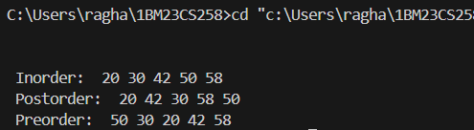

**LabProgram 09-a**

1. **Write a program to traverse a graph using BFS method.**

**Program:**

#include <stdio.h>

#include <stdlib.h>

#define MAX 100

struct Queue {

    int items[MAX];

    int front, rear;

};

struct Queue* createQueue() {

    struct Queue* q = (struct Queue*)malloc(sizeof(struct Queue));

    q->front = -1;

    q->rear = -1;

    return q;

}

int isEmpty(struct Queue* q) {

    return q->front == -1;

}

void enqueue(struct Queue* q, int value) {

    if (q->rear == MAX - 1) {

        printf("Queue is full\n");

    } else {

        if (q->front == -1) {

            q->front = 0;

        }

        q->items[++q->rear] = value;

    }

}

int dequeue(struct Queue* q) {

    int item;

    if (isEmpty(q)) {

        printf("Queue is empty\n");

        return -1;

    } else {

        item = q->items[q->front];

        if (q->front == q->rear) {

            q->front = q->rear = -1;

        } else {

            q->front++;

        }

        return item;

    }

}

void bfs(int graph[MAX][MAX], int startVertex, int n) {

    int visited[MAX] = {0};

    struct Queue* q = createQueue();

    visited[startVertex] = 1;

    enqueue(q, startVertex);

    printf("BFS Traversal: ");

    while (!isEmpty(q)) {

        int currentVertex = dequeue(q);

        printf("%d ", currentVertex);

        for (int i = 1; i <= n; i++) {

            if (graph[currentVertex][i] == 1 && !visited[i]) {

                visited[i] = 1;

                enqueue(q, i);

            }

        }

    }

    printf("\n");

}

int main() {

    int n, startVertex;

    int graph[MAX][MAX];

    printf("Enter the number of vertices : ");

    scanf("%d", &n);

    printf("Enter the adjacency matrix:\n");

    for (int i = 1; i <= n; i++) {

        for (int j = 1; j <= n; j++) {

            scanf("%d", &graph[i][j]);

        }

    }

    printf("Enter the starting vertex: ");

    scanf("%d", &startVertex);

    bfs(graph, startVertex, n);

    return 0;

}

**Output:**

Enter the number of vertices : 3

Enter the adjacency matrix:

0 1 1 1 0 1 1 1 0

Enter the starting vertex: 1

BFS Traversal: 1 2 3

**LabProgram09-b**

1. **Write a program to check whether given graph is connected or not using DFS method.**

**Program:**

#include <stdio.h>

#include <stdbool.h>

#define MAX 100 // Maximum number of vertices

// Adjacency matrix to represent the graph

int graph[MAX][MAX];

bool visited[MAX]; // Array to keep track of visited vertices

// Function to perform DFS traversal

void dfs(int vertex, int n) {

    visited[vertex] = true;

    for (int i = 0; i < n; i++) {

        if (graph[vertex][i] == 1 && !visited[i]) {

            dfs(i, n);

        }

    }

}

// Function to check if the graph is connected

bool isConnected(int n) {

    // Initialize visited array to false

    for (int i = 0; i < n; i++) {

        visited[i] = false;

    }

    // Perform DFS from the first vertex

    dfs(0, n);

    // Check if all vertices are visited

    for (int i = 0; i < n; i++) {

        if (!visited[i]) {

            return false; // If any vertex is not visited, the graph is not connected

        }

    }

    return true;

}

int main() {

    int n, edges;

    printf("Enter the number of vertices: ");

    scanf("%d", &n);

    printf("Enter the number of edges: ");

    scanf("%d", &edges);

    // Initialize the graph with 0s

    for (int i = 0; i < n; i++) {

        for (int j = 0; j < n; j++) {

            graph[i][j] = 0;

        }

    }

    printf("Enter the edges (u v) where u and v are vertices (0-based index):\n");

    for (int i = 0; i < edges; i++) {

        int u, v;

        scanf("%d %d", &u, &v);

        graph[u][v] = 1;

        graph[v][u] = 1; // Since the graph is undirected

    }

    if (isConnected(n)) {

        printf("The graph is connected.\n");

    } else {

        printf("The graph is not connected.\n");

    }

    return 0;

}

**Ouput:**

Enter the number of vertices: 4

Enter the number of edges: 3

Enter the edges (u v) where u and v are vertices (0-based index):

0 1

1 2

2 3

The graph is connected.

**LabProgram-10**

**Given a File of N employee records with a set K of Keys(4-digit) which uniquely determine the records in file F. Assume that file F is maintained in memory by a Hash Table (HT) of m memory locations with L as the set of memory addresses (2-digit) of locations in HT. Let the keys in K and addresses in L are integers. Design and develop a Program in C that uses Hash function H: K -> L as H(K)=K mod m (remainder method), and implement hashing technique to map a given key K to the address space L. Resolve the collision (if any) using linear probing**

#include <stdio.h>

#include <stdbool.h>

#define MAX 100 // Maximum number of keys in the file

#define EMPTY -1 // Sentinel value to indicate an empty location

// Function to initialize the hash table

void initializeHashTable(int hashTable[], int m) {

    for (int i = 0; i < m; i++) {

        hashTable[i] = EMPTY;

    }

}

// Hash function: H(K) = K mod m

int hashFunction(int key, int m) {

    return key % m;

}

// Function to insert a key into the hash table using linear probing

void insertKey(int hashTable[], int m, int key) {

    int address = hashFunction(key, m);

    int originalAddress = address;

    // Linear probing to resolve collisions

    while (hashTable[address] != EMPTY) {

        address = (address + 1) % m;

        if (address == originalAddress) { // Table is full

            printf("Hash table is full. Cannot insert key %d\n", key);

            return;

        }

    }

    hashTable[address] = key;

    printf("Key %d inserted at address %d\n", key, address);

}

// Function to search for a key in the hash table

bool searchKey(int hashTable[], int m, int key) {

    int address = hashFunction(key, m);

    int originalAddress = address;

    // Linear probing to search for the key

    while (hashTable[address] != EMPTY) {

        if (hashTable[address] == key) {

            return true;

        }

        address = (address + 1) % m;

        if (address == originalAddress) { // Table is fully traversed

            break;

        }

    }

    return false;

}

// Function to display the hash table

void displayHashTable(int hashTable[], int m) {

    printf("Hash Table:\n");

    for (int i = 0; i < m; i++) {

        if (hashTable[i] == EMPTY) {

            printf("Address %d: EMPTY\n", i);

        } else {

            printf("Address %d: %d\n", i, hashTable[i]);

        }

    }

}

int main() {

    int m, n;

    printf("Enter the number of memory locations (m): ");

    scanf("%d", &m);

    int hashTable[m];

    initializeHashTable(hashTable, m);

    printf("Enter the number of employee keys (n): ");

    scanf("%d", &n);

    int keys[n];

    printf("Enter %d keys (4-digit integers):\n", n);

    for (int i = 0; i < n; i++) {

        scanf("%d", &keys[i]);

    }

    // Insert keys into the hash table

    for (int i = 0; i < n; i++) {

        insertKey(hashTable, m, keys[i]);

    }

    displayHashTable(hashTable, m);

    int search;

    printf("Enter a key to search: ");

    scanf("%d", &search);

    if (searchKey(hashTable, m, search)) {

        printf("Key %d found in the hash table.\n", search);

    } else {

        printf("Key %d not found in the hash table.\n", search);

    }

    return 0;

}

**Output:**

Enter the number of memory locations (m): 10

Enter the number of employee keys (n): 5

Enter 5 keys (4-digit integers):

1234

5678

9101

1123

1456

Enter a key to search: 5678

Key 1234 inserted at address 4

Key 5678 inserted at address 8

Key 9101 inserted at address 1

Key 1123 inserted at address 3

Key 1456 inserted at address 6

Hash Table:

Address 0: EMPTY

Address 1: 9101

Address 2: EMPTY

Address 3: 1123

Address 4: 1234

Address 5: EMPTY

Address 6: 1456

Address 7: EMPTY

Address 8: 5678

Address 9: EMPTY

Key 5678 found in the hash table.

**LeetCode Problems**

**LeetCode 234**

**Palindrome Linked List**

**Program:**

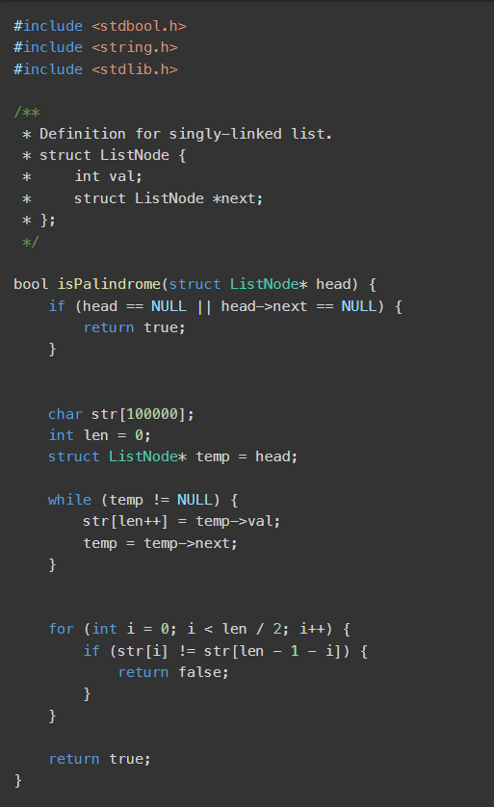

**Output:**

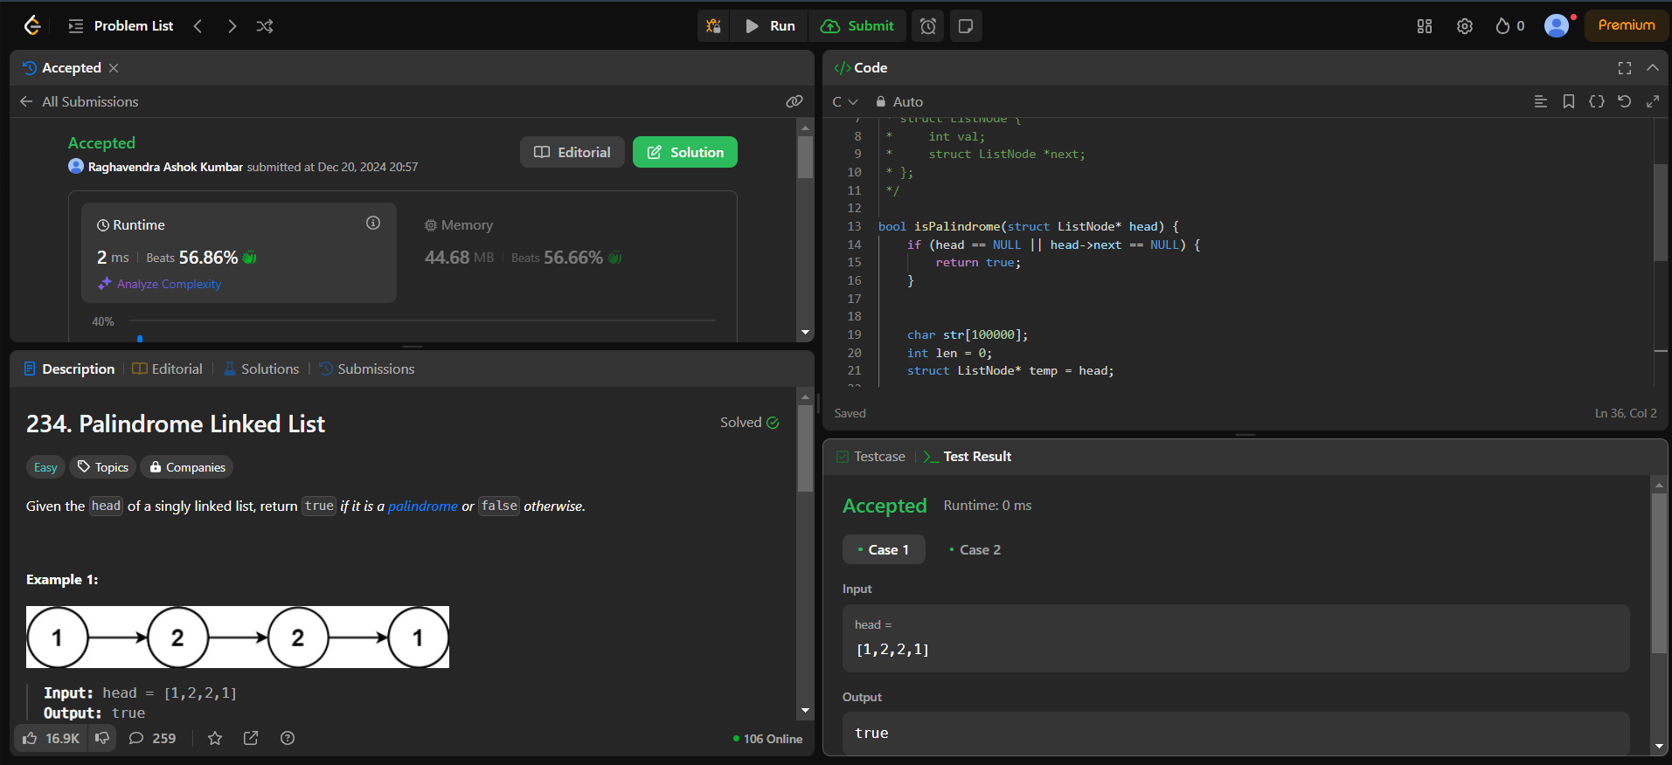

**LeetCode 169- Majority Element**

**Program:**

int majorityElement(int* nums, int numsSize){

    int sol = nums[0],

    cnt = 0;

    for (int i = 0; i < numsSize; i++) {

        if (cnt == 0) {

            sol = nums[i];

        }

        if (nums[i] == sol) {

            cnt++;

        } else {

            cnt--;

        }

    }

    return sol;

}

**Output:**

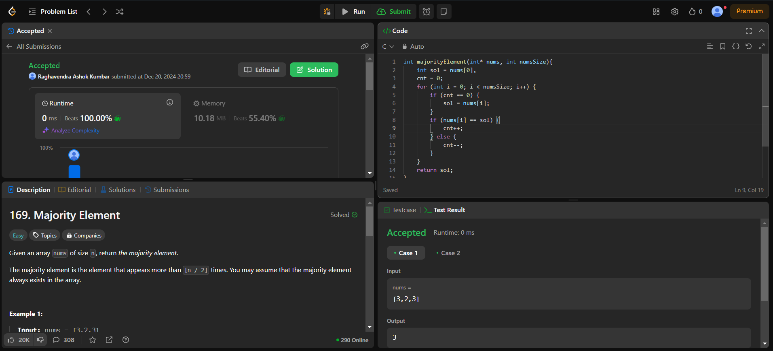

**HackerRank- Game Of Two Stacks**

**Program:**

#include <assert.h>

#include <ctype.h>

#include <limits.h>

#include <math.h>

#include <stdbool.h>

#include <stddef.h>

#include <stdint.h>

#include <stdio.h>

#include <stdlib.h>

#include <string.h>

char* readline();

char* ltrim(char*);

char* rtrim(char*);

char** split_string(char*);

int parse_int(char*);

int twoStacks(int maxSum, int a_count, int* a, int b_count, int* b) {

    int count = 0, sum = 0, x = 0, y = 0;

    while (x < a_count && (sum + a[x]) <= maxSum) {

        sum += a[x];

        x++;

        count++;

    }

    int maxi = count;

    while (y < b_count) {

        sum += b[y];

        y++;

        while (sum > maxSum && x > 0) {

            x--;

            sum -= a[x];

        }

        if (sum <= maxSum) {

            if(x+y>maxi ){

                maxi = x+y;

            }

        }

    }

    return maxi;

}

int main() {

    FILE* fptr = fopen(getenv("OUTPUT_PATH"), "w");

    int g = parse_int(ltrim(rtrim(readline())));

    for (int g_itr = 0; g_itr < g; g_itr++) {

        char** first_multiple_input = split_string(rtrim(readline()));

        int n = parse_int(*(first_multiple_input + 0));

        int m = parse_int(*(first_multiple_input + 1));

        int maxSum = parse_int(*(first_multiple_input + 2));

        char** a_temp = split_string(rtrim(readline()));

        int* a = malloc(n * sizeof(int));

        for (int i = 0; i < n; i++) a[i] = parse_int(*(a_temp + i));

        char** b_temp = split_string(rtrim(readline()));

        int* b = malloc(m * sizeof(int));

        for (int i = 0; i < m; i++) b[i] = parse_int(*(b_temp + i));

        int result = twoStacks(maxSum, n, a, m, b);

        fprintf(fptr, "%d\n", result);

        free(a);

        free(b);

        free(a_temp);

        free(b_temp);

    }

    fclose(fptr);

    return 0;

}

char* readline() {

    size_t alloc_length = 1024;

    size_t data_length = 0;

    char* data = malloc(alloc_length);

    while (true) {

        char* cursor = data + data_length;

        char* line = fgets(cursor, alloc_length - data_length, stdin);

        if (!line) break;

        data_length += strlen(cursor);

        if (data_length < alloc_length - 1 || data[data_length - 1] == '\n') break;

        alloc_length <<= 1;

        data = realloc(data, alloc_length);

        if (!data) return '\0';

    }

    if (data[data_length - 1] == '\n') data[data_length - 1] = '\0';

    else data = realloc(data, data_length + 1);

    return data;

}

char* ltrim(char* str) {

    if (!str || !*str) return str;

    while (*str != '\0' && isspace(*str)) str++;

    return str;

}

char* rtrim(char* str) {

    if (!str || !*str) return str;

    char* end = str + strlen(str) - 1;

    while (end >= str && isspace(*end)) end--;

    *(end + 1) = '\0';

    return str;

}

char** split_string(char* str) {

    char** splits = NULL;

    char* token = strtok(str, " ");

    int spaces = 0;

    while (token) {

        splits = realloc(splits, sizeof(char*) * ++spaces);

        if (!splits) return splits;

        splits[spaces - 1] = token;

        token = strtok(NULL, " ");

    }

    return splits;

}

int parse_int(char* str) {

    char* endptr;

    int value = strtol(str, &endptr, 10);

    if (endptr == str || *endptr != '\0') exit(EXIT_FAILURE);

    return value;

}

**Output:**

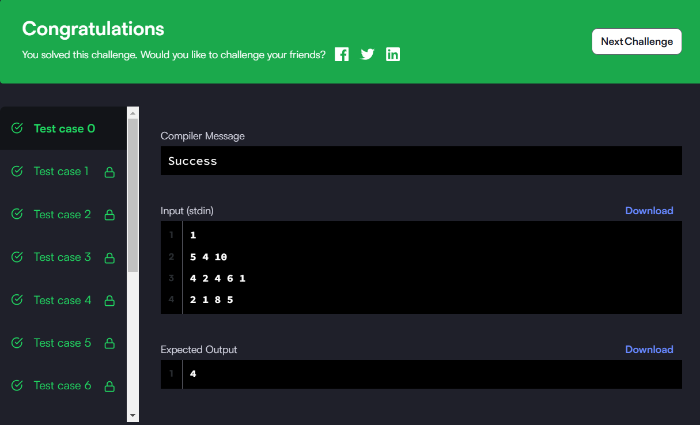

**LeetCode-112 PathSum**

**Program:**

/**

 * Definition for a binary tree node.

 * struct TreeNode {

 *     int val;

 *     struct TreeNode *left;

 *     struct TreeNode *right;

 * };

 */

bool hasPathSum(struct TreeNode* root, int targetSum) {

    if (!root)

        return false;

    if (!root->left && !root->right)

        return root->val == targetSum;

    targetSum -= root->val;

    return hasPathSum(root->left, targetSum) || hasPathSum(root->right, targetSum);

}

**Output:**



